**Citizen AI: Intelligent Citizen**

**Engagement Platform**

*Generative AI with IBM*

**

**Project Description:**

Citizen AI uses the Granite model from Hugging Face to give quick, helpful answers about government services and civic issues. It tracks public sentiment and shows simple dashboards for officials to see feedback. This project will be deployed in Google Colab using Granite for easy, low-cost setup and reliable performance.

**Pre-requisites:**

1. Gradio Framework Knowledge: Gradio Documentation
2. IBM Granite Models (Hugging Face): IBM Granite models
3. Python Programming Proficiency: Python Documentation
4. Version Control with Git: Git Documentation
5. Google Collab’s T4 GPU Knowledge: Google collab

Project Workflow:

Activity-1: To write a code for Citizen AI in GoogleColab.

Activity-2: Choosing a IBM Granite Model From Hugging Face.

Activity-3: Running Application In Google Colab.

Activity-4: Upload your Project in Github.

1.Open Google Colob and save it as HealthAI.ipynb and open a new notebook in Google Colob*.*

**

2.Search for “Hugging face” in any browser*.*

**

3.Then click on the first link (Hugging Face), then click on signup and create your own account in Hugging Face. Then search for “IBM-Granite models” and choose any model

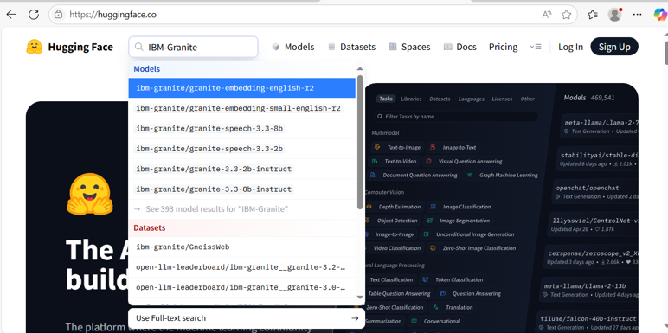

4.Here for this project we are using “granite-3.2-2b-instruct” which is compatible fast and light weight.

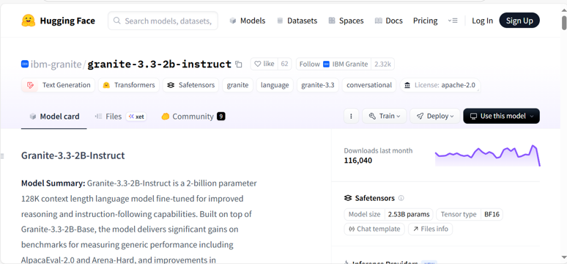

5.Now we will start building our project in Google collab.

6. Choose “T4 GPU” for Better Performance

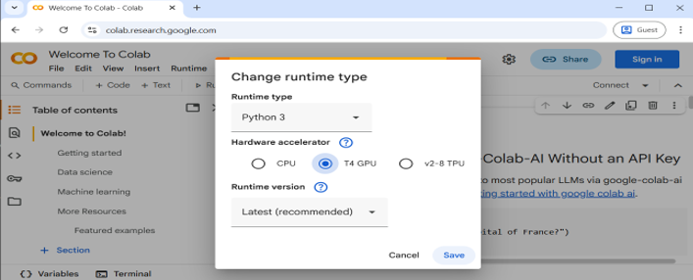

1. Then start doing the code for “Citizen AI”*.*

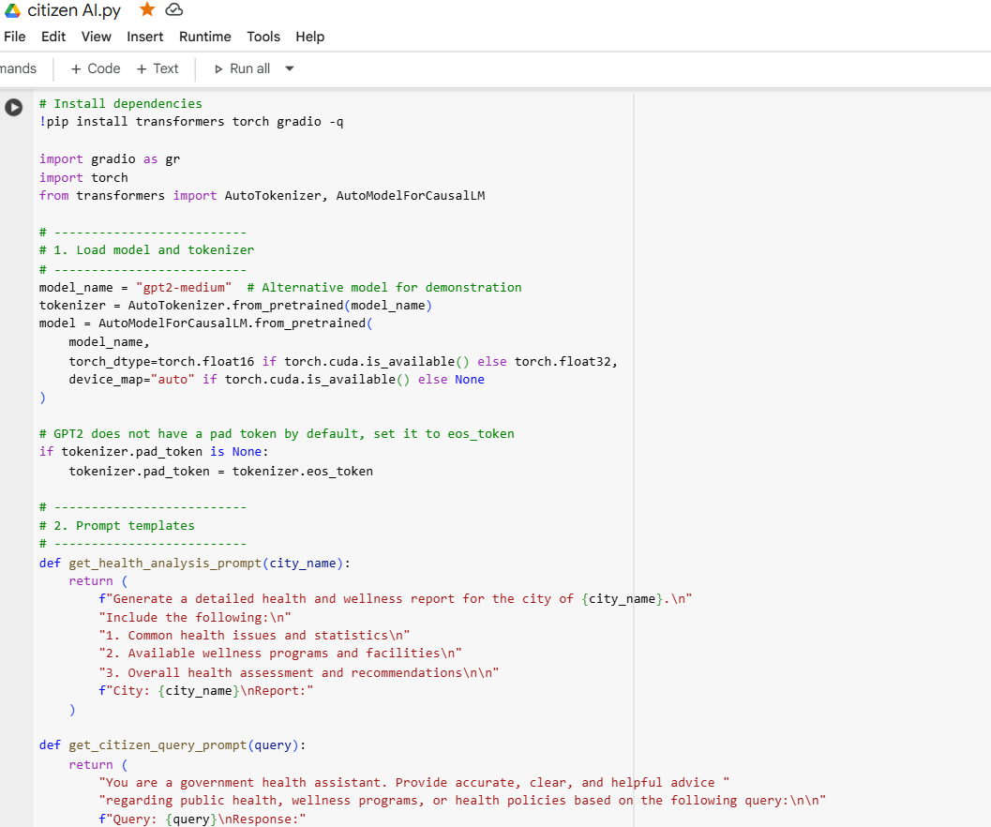

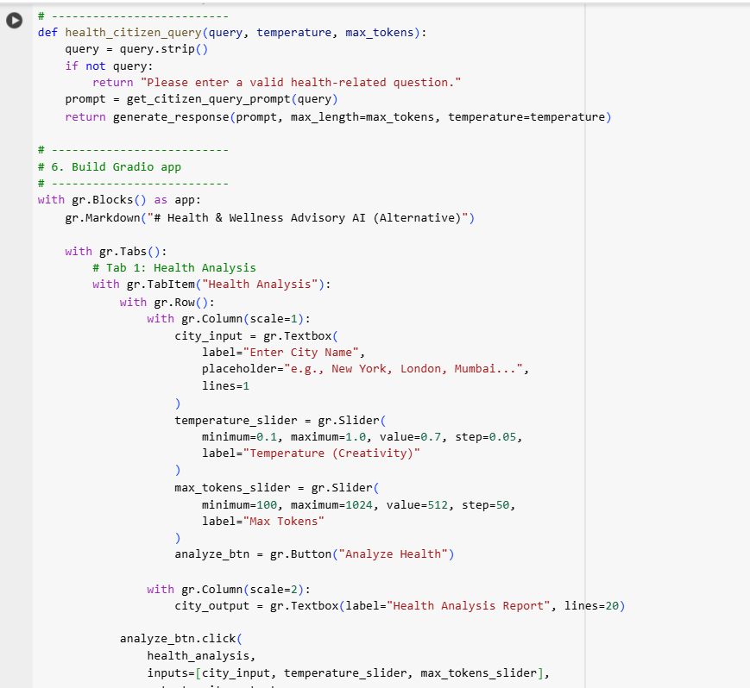

**

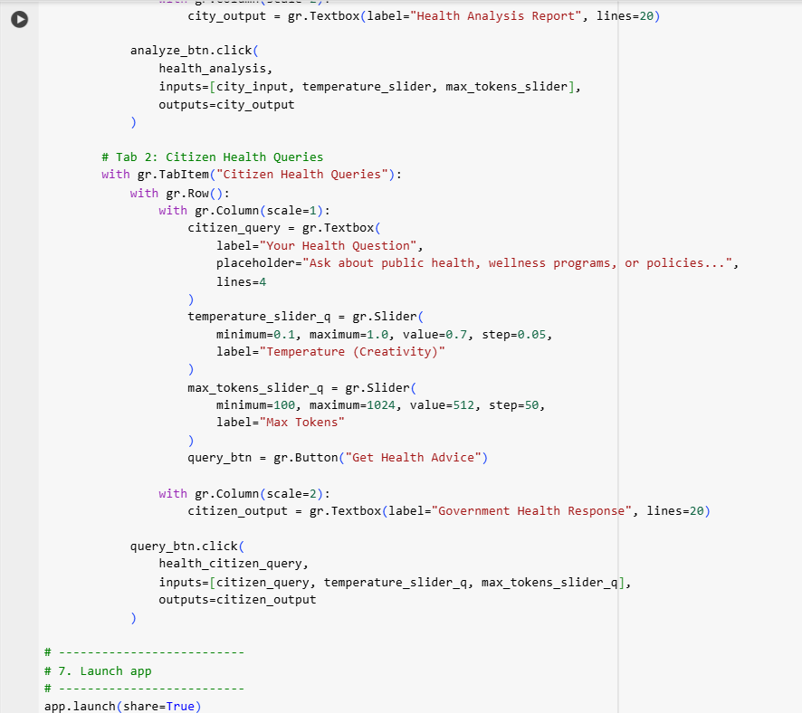

8.OUTPUT WITH A SIMPLE USER INTERFACE.

